Types of Crypto Wallets (by Storage Method):
# Source: AI Source: Provided by: [Data Path: Persons Table -> ID Column: 1, Name_En Column: Motasem Essam] -> From: [ChatGPT] on [1/21/2026]
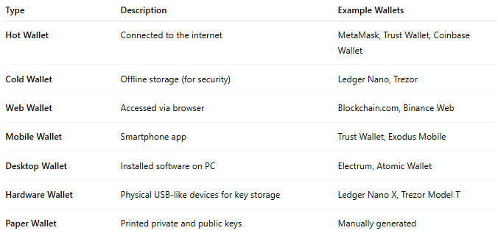

Type | Description | Example Wallets
Hot Wallet | Connected to the internet | MetaMask, Trust Wallet, Coinbase Wallet
Cold Wallet | Offline storage (for security) | Ledger Nano, Trezor
Web Wallet | Accessed via browser | Blockchain.com, Binance Web
Mobile Wallet | Smartphone app | Trust Wallet, Exodus Mobile
Desktop Wallet | Installed software on PC | Electrum, Atomic Wallet
Hardware Wallet | Physical USB-like devices for key storage | Ledger Nano X, Trezor Model T
Paper Wallet | Printed private and public keys | Manually generated

